**VOICE BASED LIBRARY MANAGEMENT SYSTEM**

**ABSTRACT**

Library Management System is a project to organize the management of library in an efficient manner. It aims in improving the system by using the voice-based mechanism. It has an admin portal which is very much comfortable and easy in using. It gives a centralized library management. It is not constrained to a particular system, that is, it can be accessed anywhere and anytime, only by the admin. The user can search for a book in the library using this system via voice. If the book is in the library, it displays. The same way, the admin can search for a book using voice and add the book to the database easily.

**CHAPTER 1**

**I.INTRODUCTION**

**1.1AIMS AND OBJECTIVES**

The main objective of the Library Management system is discipline of the planning, organizing and managing the library tasks. Our project aims at making the task of library easy. Library Management is entering the records of new book and retrieving the details of book available in the library. We can make this work easier by making it voice based system. It is comparatively faster and easier than the existing system. In the project we can maintain the track of library books whether is available or not.

The project objectives are

* To eliminate the paperwork
* To record every book coming into the library
* To design a user-friendly graphical user interface which suits all the users
* To accommodate large sized library
* To aid visually challenged people

**1.2NEED FOR THE STUDY**

The existing system has been in the service for years. It lacks novelty and is failing to adapt to the present generation. To overcome the said demerit, we have modified the system with the ability to respond to user’s command. It includes the voice-based searching system. It is quite faster and accurate when you have a reliable internet connection. Since it uses one of the foremost and sought after API’s of google, it can have the faith, it deserves.

1. **Accessibility:** The database is made online, the user can search online whether the book they are searching for is present in the library or not.
2. **Transparency:** The books that are available in the library, are only get loaded into the database. So, no false play is happening in here.
3. **Speed:** The data available are real time and it provides accurate data in real quick.

**CHAPTER 2**

**II.REVIEW OF LITERATURE**

**2.1INTRODUCTION**

To offer the voice-based library management system, it is important to know about the existing system and how it works. By making it online, we can reduce the works being done through paper.

**2.2LIBRARY MANAGEMENT SYSTEM**

According to Stephen, Maeve & Philips (2007), in a traditional sense, a Library is a large collection of books, and can refer to the place in which the collection is housed. Today, the term can refer to any collection, including digital sources, resources, and services. The collections can be of print, audio, and visual materials in numerous formats, including maps, prints, and documents, microform, CDs, cassettes, videotapes, DVDs, video games, e-books, audio books and many other electronic resources. The places where this material is stored can range from public libraries, subscription libraries, private libraries, and can also be in digital form, stored on computers or accessible over the internet. The term has acquired a secondary meaning: "a collection of useful material for common use." This sense is used in fields such as computer science, mathematics, statistics, electronics and biology. They add that, a library is organized for use and maintained by a public body, an institution, a corporation, or a private individual. Public and institutional collections and services may be intended for use by people who choose not to or cannot afford to purchase an extensive collection themselves, who need material.

**2.2.1DISADVANTAGES**

According to Burke (2007) Manual Library Management systems, operating systems are vulnerable to human error. For instance, a librarian who misfiles a borrower's records or indexes a book incorrectly slows down the process and wastes students' time. Manual systems are also slow to operate. Instead of using a computer to issue and take back books, locating and updating a card index is slow and laborious. Manual systems are unable to store large amounts of data efficiently. With manual systems Librarian spend a lot of their time on mechanical, clerical tasks rather than liaising with library visitors.

**CHAPTER 3**

**III.SYSTEM ANALYSIS**

**3.1EXISTING SYSTEM**

The library management systems landscape has changed considerably over the last few years. Some of the biggest vendors have merged or been acquired by other companies (e.g. Sirsi and Dynix; Ex Libris and Endeavor Information Systems) and this has resulted in some of the most popular systems being withdrawn. Systems librarians have been worried about the fall-out from these developments. These new issues with LMS vendors come on top of complaints many systems librarians have had for years, such as poor support, limited flexibility, lack of interest in new developments, as well as the high cost of the initial implementation, annual license and support charges. With [open source software](https://www.sciencedirect.com/topics/computer-science/open-source-software) (OSS) products, such as Moodle for [Virtual Learning Environments](https://www.sciencedirect.com/topics/computer-science/virtual-learning-environments) (VLEs) and DSpace and EPrints for [institutional repositories](https://www.sciencedirect.com/topics/computer-science/institutional-repository), taking off in related areas, many librarians are beginning to watch out for OSS solutions when replacing their current LMS.

Selecting your new system is the most important part of the planning process for revitalising your LMS. If you have spent many work hours planning for your new LMS, the last thing you want is to have selected a system that doesn’t work the way you expected it to. As Gerhard Bissels comments above, the lack of choice and cost for licensing a proprietary LMS are driving many libraries to look at OSS options. Public libraries have developed several OSS options to design a system that suits their need. Koha and Evergreen were initially designed by public libraries or public [library consortia](https://www.sciencedirect.com/topics/computer-science/library-consortium) that were frustrated by the existing commercial options.

**3.2PROPOSED SYSTEM**

The system involves creating a web page, using hypertext pre-processor, which is used for speech recognition. On opening the page, a button in the shape of mic is displayed, clicking that enables the microphone. The user has to search for the book with the pretext of ‘search for’ command. With the strong internet connection, in the matter of seconds, the results are displayed. If the book you are searching for is present in the library, it displays the same, else not available. It has an admin portal which uses the same mechanism above mentioned to add the books to the library. By adding means, we are virtually adding the book to the library. In the real context, the book is added to the database of the library. In the same way, the book can be removed from the library too.

The system involves Google speech recognition API which is quite fast and the best in the market too. In addition to that, the book to be searched are taken from the Google books API. If the searched book is not available in the library, it gives the e-pdf of that book from the Google books, so the user will get the book anyway.

**3.2.1ADVANTAGES**

1. The availability of books are reliable and assurance of the presence of the books are ensured
2. The books that are added to the database are only shown.
3. The user can check the availability of books anywhere, anytime.
4. The centralised management makes it easy for the users as well as for the admin

**3.3FEASIBILITY STUDY**

This section provides the overview of the economic, operational and technical feasibility of the project for real time implementation.

**3.3.1ECONOMIC FEASIBILITY**

The main part of the expenditures of the project is software costs. This includes the initial investment of the required software for executing the project in the system.

**CHAPTER 4**

**IV.SYSTEM MODULES**

**4.1USER MODULE**

User interface has this web page where the user can search for a book using this voice. The result page has the information about the book, the user has searched. And it displays whether the book is available in the library. If it is available, it displays. If not, it brings the pdf version of the book from Google books API.

**4.2ADMINISTRATOR MODULE**

The administrator module has the login page specifically designed for the admin to work with the library database. Once passed the login page, the admin works with the same way, the user works. The admin searches for the book using voice command and the book is brought from the Google books and the admin now can add the book to the library database. These things are working in real time. The admin can work anywhere and is not constrained to only the campus or the library.

**CHAPTER 5**

**V.SOFTWARE REQUIREMENTS**

**5.1INTRODUCTION**

The following describes the software and the system required to operate the library management system.

**5.2PURPOSE**

The purpose of this document is to provide software requirement specifications for ‘voice-based library management system’. Thereby the modern method of library management system is explained through this.

**5.3SOFTWARE DESCRIPTION**

Though there are numerous operating systems found in the field of Information Technology, this project works platform independently.

Operating System:

Languages Used: PHP, MySQL, JavaScript

Tools Used: Atom, Apache server

API : Google Books, Google Speech to Text API

**CHAPTER 6**

**VI.EXPERIMENTS**

**6.1SCREENSHOTS:**

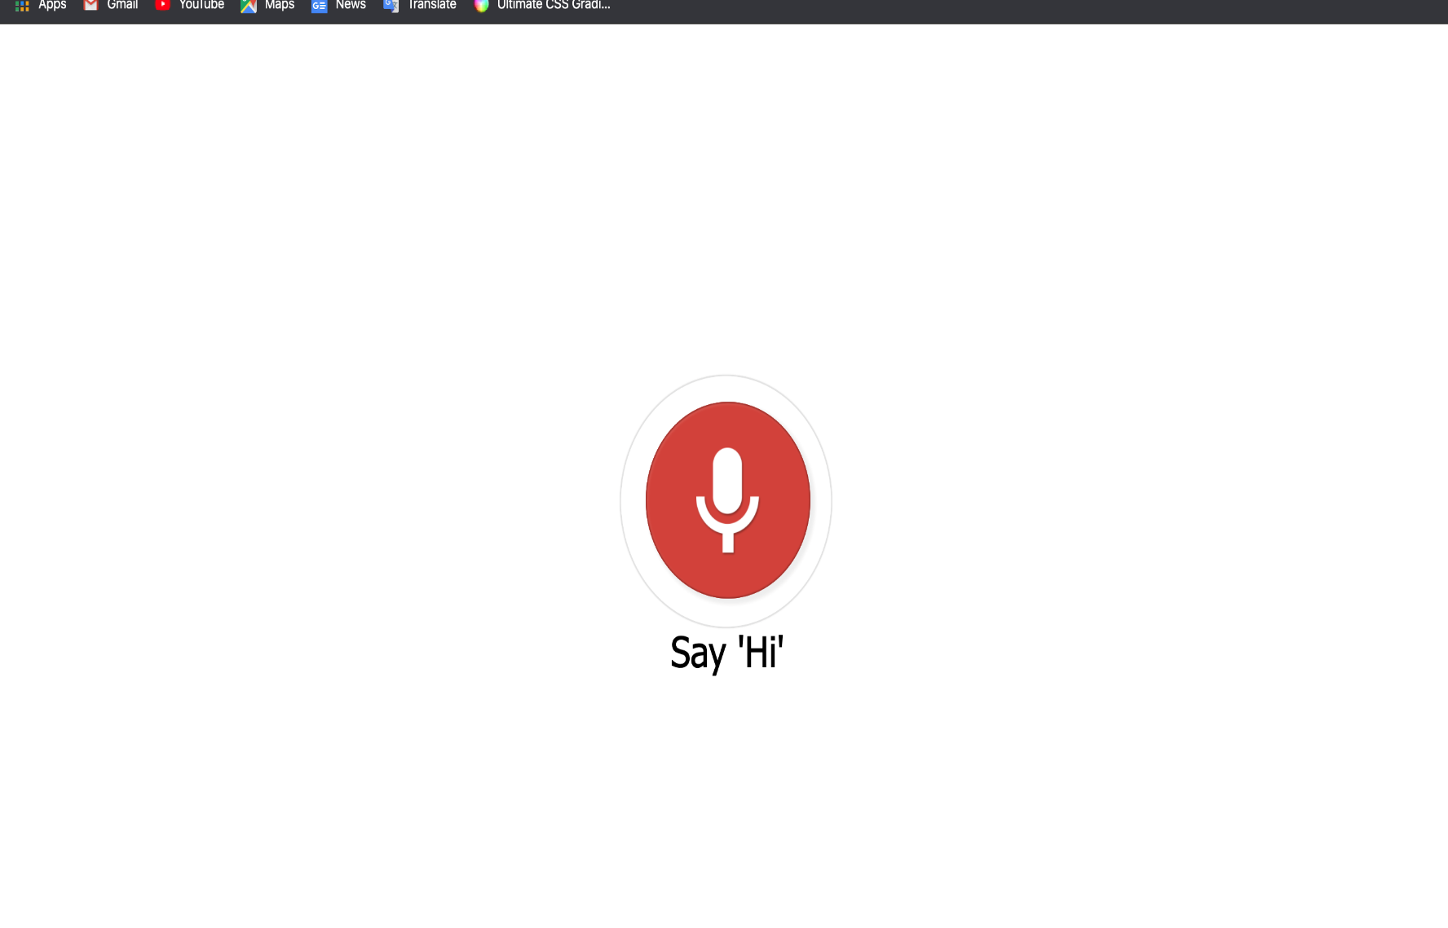

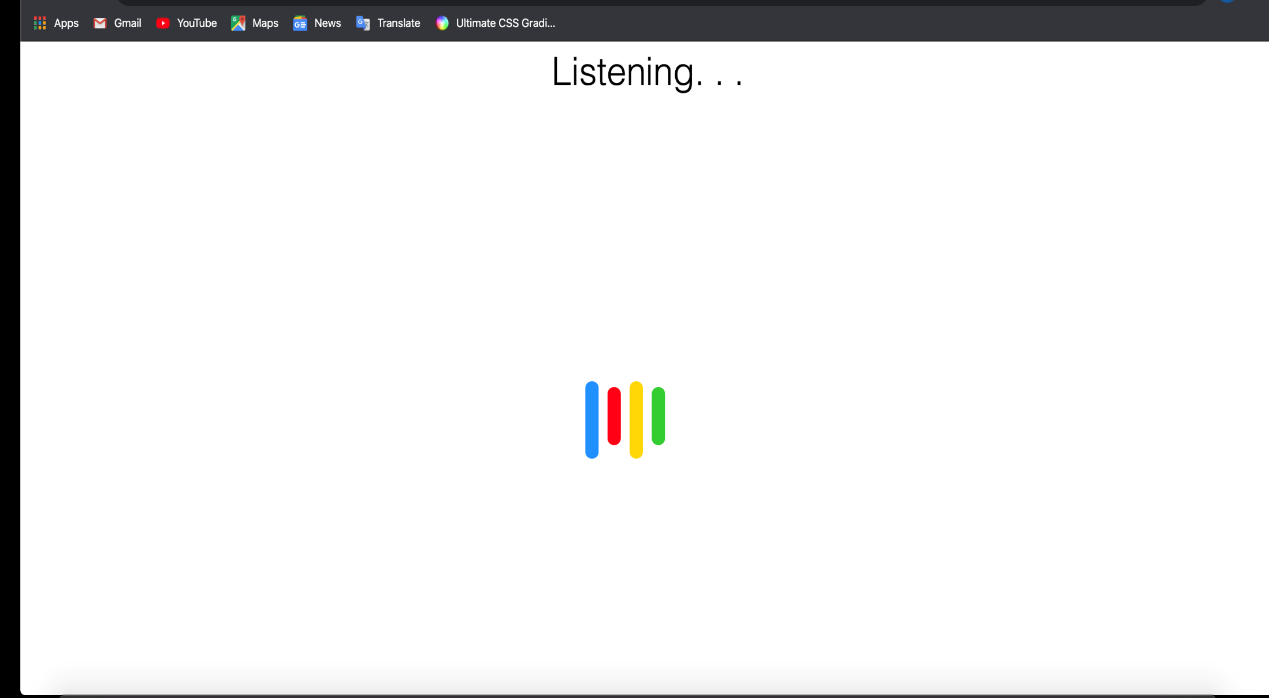

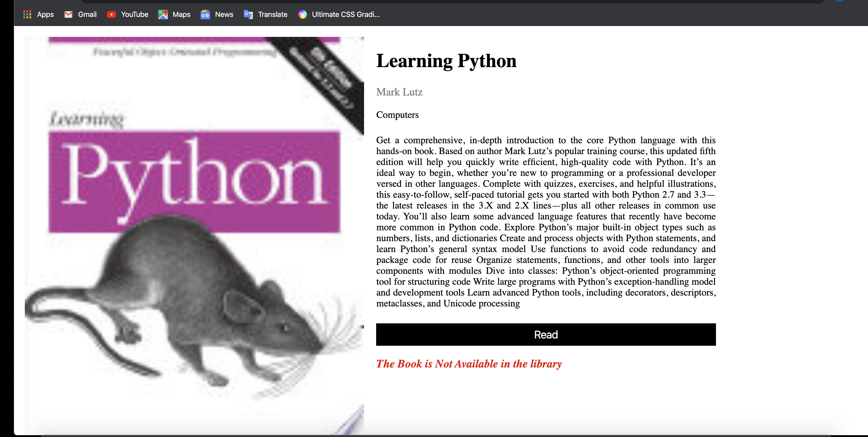

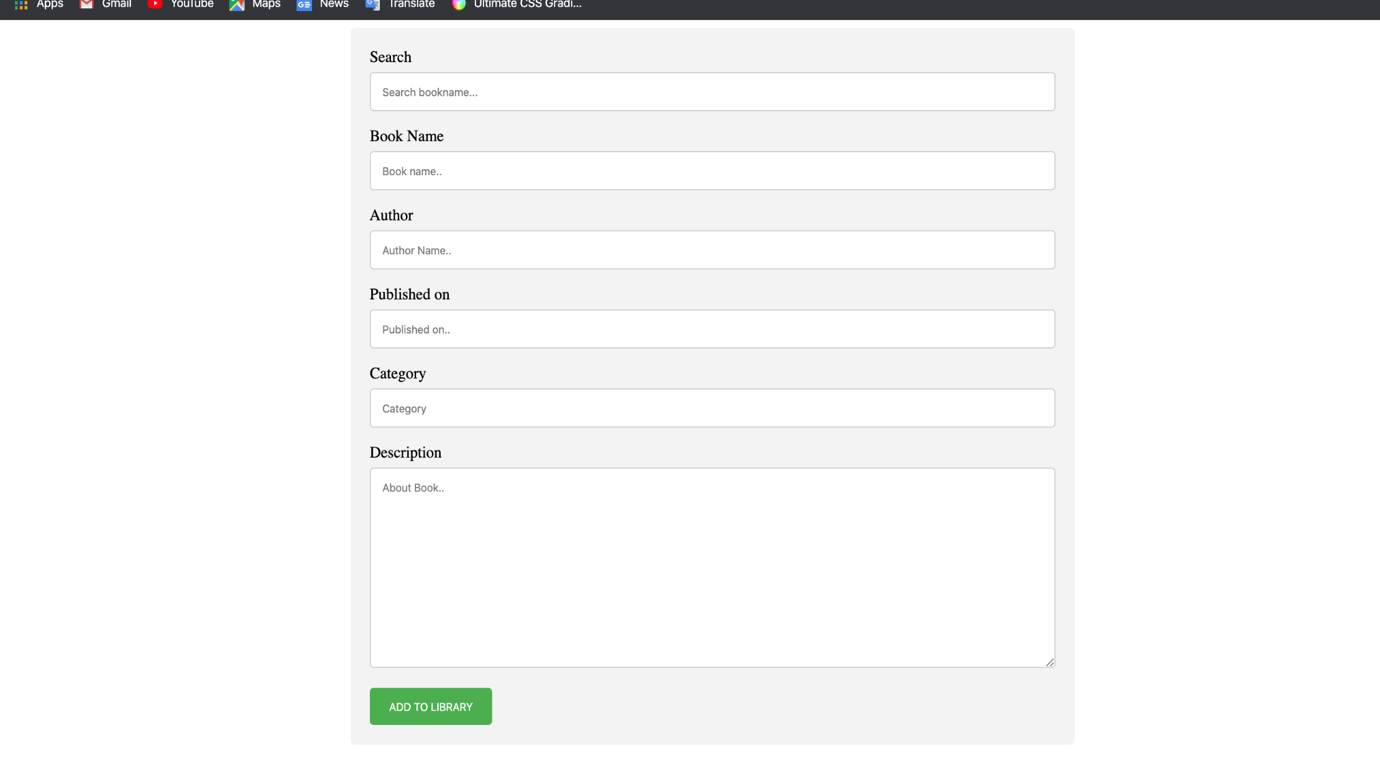

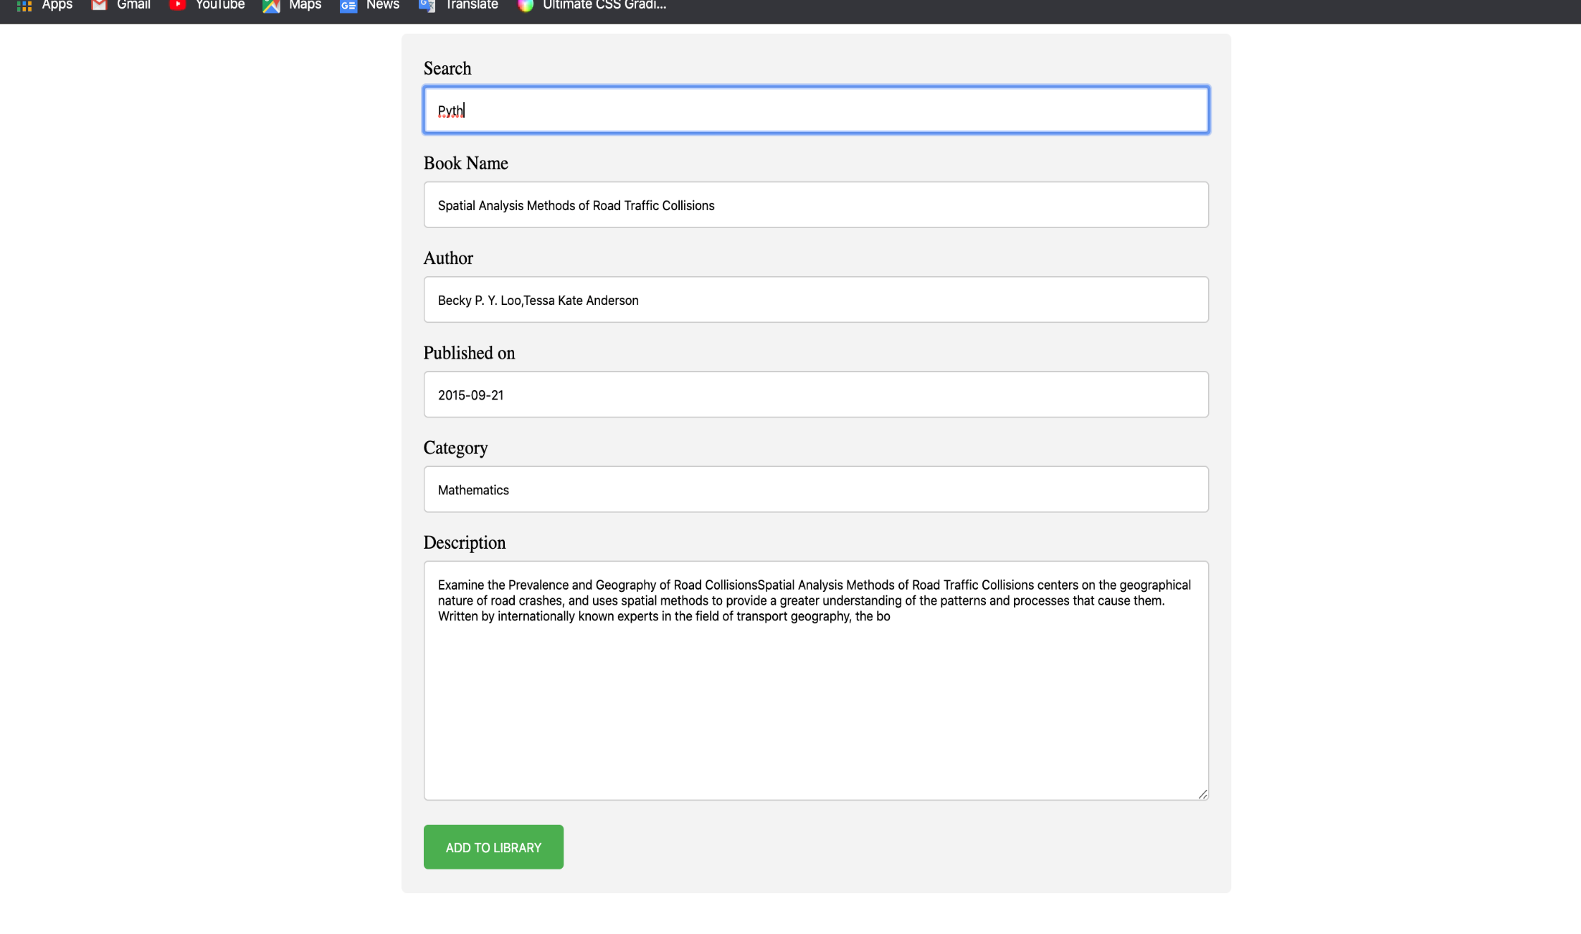

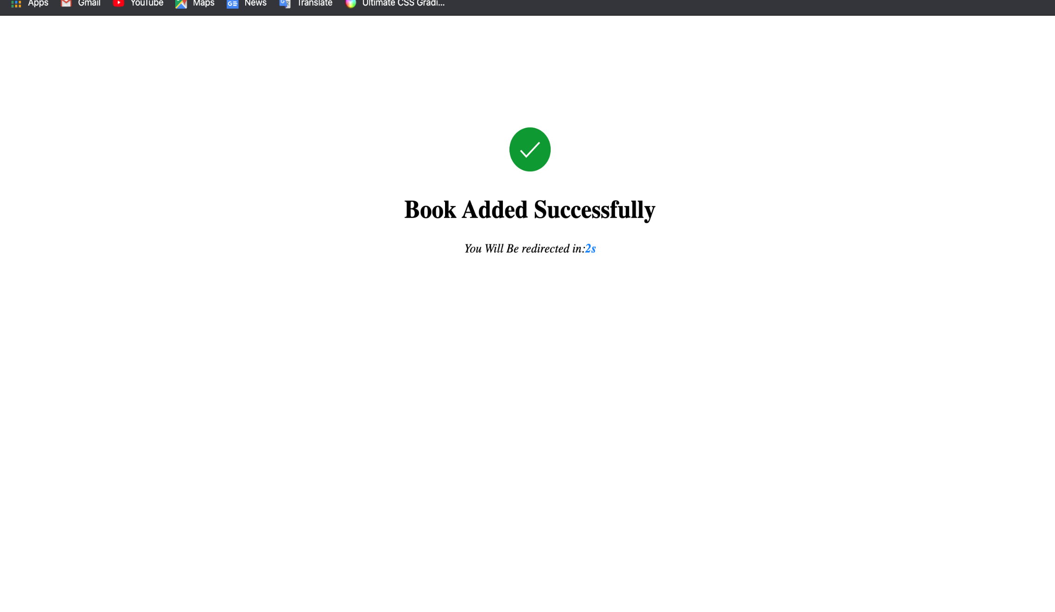

**CHAPTER 7**

**VII.CONCLUSION**

By doing this project we were able to bring a new system for library management system. With the advent of technology and Internet in our day to day life, we were able to offer advanced library management system to the users.

**CHAPTER 8**

**VIII.REFERENCES**

<https://ampletrails.com/library-management-system/>

<https://www.alfaebooks.com/electronic_library_management_system>

<https://www.academia.edu/25553795/Library_Management_system_Problem_and_its_Background_Problem_and_its_Background>

<https://www.grin.com/document/205391>

<https://www.studentprojectguide.com/project-report/library-management-system-project-report/>